SIMATS ENGINEERING (SAVEETHA SCHOOL OF ENGINEERING)
CO2 ASSESSMENT TOOL 2 — Architecture Design Assignment
Course Code: | CSA1007 | Course Title: | Software Engineering
CO Assessed: | CO2 | Assessment: | Assessment Tool 2 – Architecture Design Assignment
Weightage: | 20% | Total Marks: | 25
CO2 Statement: | Perform detailed requirements analysis, design scalable architectures, and prioritize features with a focus on cross-disciplinary skills.
Student Name: | D. Vyshali | Reg. No.: | 192411197
Date: | 28/08/2026 | Duration: | 60 minutes

Code of Conduct
I, D. Vyshali (192411197), certify that this submission is my original work and that I have adhered to the guidelines specified for this assessment. I understand that any violation of academic integrity rules will result in disciplinary action.
Signature of the Student: D. Vyshali
Date of submission: 30/07/26

Problem Statement 17: AI-Based Fashion Supply Chain Optimization Platform

1. Analyze System Requirements

1.1 System Overview and Objectives
The assigned problem statement calls for an AI-Based Fashion Supply Chain Optimization Platform that forecasts product demand, optimizes inventory allocation across warehouses and stores, coordinates suppliers, tracks shipments, monitors sales trends, and generates consolidated supply chain performance reports. Fashion retail is characterized by short product lifecycles, strong seasonality, and multi-tier supply networks, so the architecture must support frequent model retraining, high-frequency data ingestion from point-of-sale and logistics systems, and consolidated reporting for business stakeholders spread across regions.
The core system objectives that drive the architectural design are:
- Forecast product demand using historical sales, seasonality, and trend data.
- Optimize inventory allocation across warehouses and retail stores.
- Coordinate suppliers for timely, reliable replenishment.
- Track shipments in real time across the logistics network.
- Monitor sales trends to detect fast- and slow-moving products.
- Generate consolidated supply chain performance reports.

1.2 Functional Requirements Influencing the Architecture
The following functional capabilities directly shape how the system must be partitioned into components and how those components must communicate:
- An AI/ML forecasting engine that runs demand prediction jobs independently of transactional workloads, so it can be scaled and retrained without affecting order processing.
- An inventory allocation engine that continuously compares forecasts against live stock and issues allocation recommendations to warehouses and stores.
- A supplier coordination module that generates purchase orders and exchanges status updates with external supplier systems (API/EDI).
- A shipment tracking module that ingests continuous, high-frequency location and status events from third-party carrier APIs.
- A sales trend monitoring module that processes point-of-sale event streams to flag fast-moving and slow-moving products in near real time.
- A reporting and dashboard module that aggregates data from every other module for executives and managers.
- A user and access management module enforcing role-based access across business, supplier, and internal users.

1.3 Non-Functional Requirements and Quality Attributes
Because forecasting, allocation, supplier coordination, shipment tracking, and reporting have very different load patterns, resource needs, and release cadences, the architecture must let each concern evolve, scale, and fail independently. The key quality attributes identified are summarized below.
Quality Attribute | Requirement Driving the Architecture
Scalability | The system must scale horizontally as regions, stores, and SKUs grow, and must allow the forecasting engine to scale independently of transactional modules during peak seasonal load.
Performance | Demand forecasts should be generated within 5 seconds per SKU query; dashboards should load within 3 seconds; shipment status must reflect within 15 minutes of a carrier update.
Reliability / Availability | The platform must maintain at least 99.5% uptime; a failure in one module (e.g., shipment tracking) must not bring down forecasting or reporting.
Security | Data must be encrypted in transit and at rest, with role-based access control and multi-factor authentication for administrative and supplier-facing roles.
Maintainability | Forecasting and allocation models must be retrainable and independently deployable without a full system redeployment.
Interoperability | The platform must integrate with existing ERP/POS systems, supplier EDI/API systems, and logistics carrier tracking APIs.

2. Select a Suitable Software Architecture

2.1 Selected Architecture: Cloud-Native Microservices with Event-Driven Communication
A Microservices Architecture, supported by an API Gateway for client-facing access and an event-driven message broker for asynchronous data flows, is selected as the most suitable architectural style for the AI-Based Fashion Supply Chain Optimization Platform.

2.2 Justification
- Independent, heterogeneous modules: Demand forecasting is a compute-intensive AI/ML workload, while inventory allocation, supplier coordination, and reporting are transactional and query-driven. Microservices allow each module to be built, scaled, and deployed on the technology stack best suited to its own workload.
- Independent scalability: Seasonal spikes (e.g., pre-festive demand forecasting or peak shipment volumes) can be absorbed by scaling only the affected service, rather than the entire monolith, which directly satisfies the scalability requirement.
- Fault isolation: If the shipment tracking service experiences a carrier API outage, forecasting, allocation, and reporting continue to operate normally, supporting the 99.5% availability target.
- Asynchronous, high-volume data ingestion: Point-of-sale sales events and carrier shipment updates arrive continuously and at high frequency. An event-driven backbone (message broker) decouples producers (POS, carriers) from consumers (trend monitoring, shipment tracking), preventing slow consumers from blocking upstream systems.
- Independent release cycles: Forecasting models need frequent retraining and redeployment; microservices allow the forecasting service to be updated without redeploying supplier coordination or reporting services, supporting maintainability.
- Straightforward third-party integration: An API Gateway provides a single, secured entry point for external suppliers and internal clients, simplifying authentication, rate limiting, and monitoring of external integrations (ERP/POS, supplier EDI, carrier APIs).
A pure monolithic or simple layered architecture was considered but rejected, since it would force the compute-intensive forecasting workload and the high-frequency shipment/sales event streams to share the same scaling and deployment unit as transactional modules, making it difficult to meet the performance and availability targets during seasonal peaks. A Service-Oriented Architecture (SOA) with a heavyweight enterprise service bus was also considered, but was judged to introduce unnecessary complexity and a central point of failure compared to a lightweight, independently deployable microservices approach combined with a message broker.

3. Software Architecture Diagram
The diagram below illustrates the overall structure of the proposed platform, including the presentation layer, API Gateway, the microservices layer, the event-driven message broker, the polyglot data layer, and external system integrations.
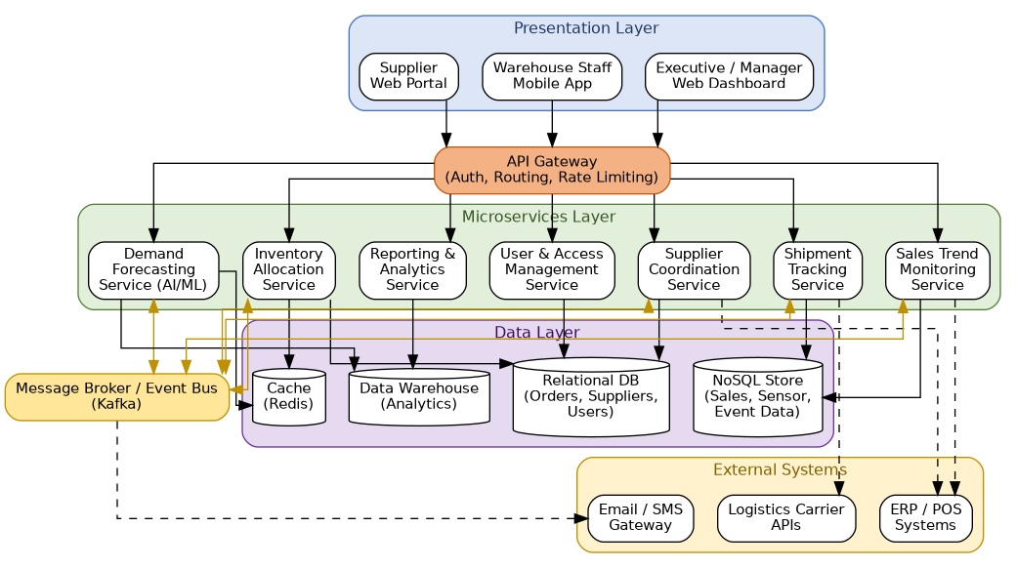
Figure 1: Proposed Microservices Architecture — AI-Based Fashion Supply Chain Optimization Platform

4. Explain Components and Their Interactions

4.1 Component Responsibilities
Component | Responsibility
Web Dashboard / Mobile App / Supplier Portal | Client interfaces used by executives, supply chain managers, warehouse staff, and suppliers to interact with the platform.
API Gateway | Single entry point that authenticates requests, applies role-based access control, routes traffic to the correct microservice, and enforces rate limiting.
Demand Forecasting Service | AI/ML engine that generates SKU/region/season-level demand forecasts with confidence intervals from historical sales, seasonality, and trend data.
Inventory Allocation Service | Compares forecasts with current stock levels and recommends store-wise/warehouse-wise allocation, supporting manager overrides.
Supplier Coordination Service | Tracks supplier performance metrics and generates/transmits purchase orders, receiving acknowledgements and status updates.
Shipment Tracking Service | Consumes carrier status events and maintains real-time shipment location and status information.
Sales Trend Monitoring Service | Analyzes point-of-sale event streams to detect fast- and slow-moving products and emerging trends.
Reporting & Analytics Service | Aggregates data from all services into consolidated KPIs, executive dashboards, and scheduled/on-demand reports.
User & Access Management Service | Authenticates users, enforces role-based permissions, and maintains an audit trail of key actions.
Message Broker / Event Bus | Decouples event producers (POS, carriers) from consumers (trend monitoring, shipment tracking, notifications), enabling asynchronous, scalable data flow.
Data Layer (Relational DB, NoSQL Store, Cache, Data Warehouse) | Persists transactional data, high-volume event data, frequently accessed data, and historical data for analytics, respectively.
External Systems (ERP/POS, Carrier APIs, Notification Gateway) | Third-party systems integrated via secure REST/EDI APIs for sales data, shipment tracking, and email/SMS alerts.

4.2 Communication and Workflow
Clients communicate with the platform exclusively through the API Gateway, which authenticates each request and routes it to the relevant microservice over secure REST/HTTPS APIs. Synchronous, request-response interactions — such as a manager requesting a demand forecast or an executive opening a dashboard — flow through the gateway directly to the corresponding service, which reads from its own data store (using a cache for frequently requested data such as recent forecasts).
High-frequency, continuous data — point-of-sale sales events, carrier shipment updates, and inter-service notifications — flow through the message broker instead of direct synchronous calls. For example, when the carrier API reports a shipment delay, the Shipment Tracking Service publishes an event to the broker; the Notification module and the Reporting Service subscribe to this event independently, updating warehouse staff and the executive dashboard without the Shipment Tracking Service needing to know about either downstream consumer. Similarly, the Sales Trend Monitoring Service consumes POS events published to the broker, and once it detects a significant demand shift, it publishes a trend alert that the Demand Forecasting Service and Reporting Service can subscribe to.
The overall workflow proceeds as follows: (1) historical and live sales data feeds the Demand Forecasting Service; (2) forecasts are consumed by the Inventory Allocation Service to propose stock distribution; (3) approved allocations that require replenishment trigger purchase orders through the Supplier Coordination Service; (4) dispatched orders are tracked by the Shipment Tracking Service until delivery; and (5) the Reporting & Analytics Service continuously aggregates outputs from every stage into consolidated dashboards and reports for business stakeholders.

5. Discuss Quality Attributes

5.1 Scalability
Each microservice can be scaled independently based on its own load profile. During peak seasonal planning, the Demand Forecasting Service can be scaled out on additional compute/GPU instances, while lighter services such as Supplier Coordination remain at baseline capacity. The event-driven backbone further allows sales and shipment event volume to grow without requiring synchronous capacity across every consumer.

5.2 Security
The API Gateway centralizes authentication and enforces role-based access control with multi-factor authentication for administrative and supplier-facing roles, so individual services do not need to duplicate security logic. Data is encrypted in transit (HTTPS/TLS) and at rest across all data stores, and the User & Access Management Service maintains a full audit trail of sensitive actions such as order approvals and allocation overrides.

5.3 Performance
Separating the compute-intensive forecasting workload from transactional services prevents forecast generation from degrading dashboard or order-processing response times. A caching layer serves frequently requested forecasts and allocation data, helping meet the 5-second forecast and 3-second dashboard load targets, while the message broker ensures shipment status updates propagate to consumers within the required 15-minute window.

5.4 Reliability
Because services are loosely coupled through the message broker, a temporary failure or slowdown in one service — for example, the Shipment Tracking Service during a carrier API outage — does not cascade to the Demand Forecasting, Allocation, or Reporting services. Failed events can be retried or queued in the broker without permanent data loss, improving overall system resilience.

5.5 Maintainability
Each microservice has clear, bounded responsibilities, so the AI/ML forecasting model can be retrained and redeployed independently of the rest of the platform. New forecasting algorithms, additional supplier integrations, or new report types can be introduced as isolated changes without requiring a full-system redeployment.

5.6 Availability
Multiple service instances run behind the API Gateway with health-checked load balancing, and the data layer uses replication for the relational database and data warehouse. This redundancy, combined with fault isolation between services, supports the target of 99.5% platform uptime.

6. Justify Architectural Decisions

6.1 Rationale
The combination of microservices, an API Gateway, and an event-driven message broker was chosen because the platform's workloads are fundamentally heterogeneous: compute-intensive AI/ML forecasting, transactional inventory and supplier operations, and high-frequency streaming data from POS and carrier systems each have different scaling, latency, and reliability needs. A single unified style — whether a monolith or a simple layered design — would force all of these workloads to share the same deployment and scaling unit, making it difficult to meet the seasonal scalability and availability requirements identified in Section 1.3.

6.2 Trade-offs Considered
- Operational complexity: Microservices introduce additional operational overhead (service discovery, distributed monitoring, inter-service network calls) compared to a monolith. This is accepted because the independent scalability and fault isolation benefits outweigh the added complexity for a platform of this scale and heterogeneity.
- Eventual consistency: Using an event-driven broker for cross-service updates (e.g., shipment status reaching the dashboard) means some data is only eventually consistent rather than instantly consistent. This is acceptable given the 15-minute shipment update requirement, and is far preferable to tightly coupling every service through synchronous calls.
- Infrastructure cost: Running multiple independently deployed services and a message broker has a higher baseline infrastructure cost than a monolith. This is justified by the reduced business cost of downtime, missed forecasting windows, and slower seasonal scaling.

6.3 Support for Future Enhancements and Long-Term Maintainability
The chosen architecture supports future growth in several ways. New capabilities — such as an offline/degraded mode for warehouses with intermittent connectivity, forecast explainability features, or additional regional markets — can be added as new services or extensions to existing ones without redesigning the platform. The API Gateway and event-driven broker make it straightforward to onboard additional external integrations (new carriers, new ERP systems, new supplier portals) by adding routing rules and event subscribers rather than modifying core business logic. Because each service is independently deployable and testable, the platform can evolve incrementally, reducing regression risk and supporting long-term maintainability as the fashion retailer's supply chain network grows.

7. Conclusion
This Architecture Design Analysis has examined the AI-Based Fashion Supply Chain Optimization Platform's system requirements and quality attributes, selected and justified a cloud-native microservices architecture with event-driven communication, presented the overall architecture diagram, explained component responsibilities and interactions, evaluated the design against key quality attributes, and justified the architectural trade-offs and long-term maintainability — providing a sound architectural foundation for subsequent detailed design and implementation.

